|  |
| --- |
| Serial No: |
| **Final**  **Part C** |
| **Total Time: 1 Hours** |
| **Total Marks: 50** |
| ________________  Signature of Invigilator |

|  |
| --- |
| **CS-307 Computer Networks** |
| Thursday, December 21, 2017 |
| **Course Instructors** |
| Dr. Ehtesham Zahoor, Dr. Kashif Munir and  Dr. Muhammad Asim |

|  |
| --- |
| **______________________________ _________ ______ _____________________**  Student NameRoll No Section Signature |

## DO NOT OPEN THE QUESTION BOOK OR START UNTIL INSTRUCTED.

**Instructions:**

1. Attempt on question paper. Attempt all of them. Read the question carefully, understand the question, and then attempt it.
2. No additional sheet will be provided for rough work.
3. After asked to commence Part C, please verify that you have **Six (6)** different printed pages including this title page. There are total of **five (5)** questions.
4. Use permanent ink pens only. Any part done using soft pencil will not be marked and cannot be claimed for rechecking.

|  |  |  |  |  |  |  |
| --- | --- | --- | --- | --- | --- | --- |
|  | Q-3 | Q-4 | Q-5 | Q-6 | Q-7 | **Total** |
| **Marks Obtained** |  |  |  |  |  |  |
| **Total**  **Marks** | 10 | 10 | 10 | 10 | 10 | **50** |

**Vetted By: _____________________________ Vetter Signature: _____________________**

**Question No.3: [10 Marks]**

|  |  |  |  |  |  |  |  |  |  |  |  |  |  |  |  |  |  |  |  |  |  |  |  |  |  |  |  |  |  |  |  |  |  |  |  |  |  |  |  |  |  |  |  |  |
| --- | --- | --- | --- | --- | --- | --- | --- | --- | --- | --- | --- | --- | --- | --- | --- | --- | --- | --- | --- | --- | --- | --- | --- | --- | --- | --- | --- | --- | --- | --- | --- | --- | --- | --- | --- | --- | --- | --- | --- | --- | --- | --- | --- | --- |
| 1. A datagram of 5020 bytes arrives at a router and must be forwarded to a link with an MTU of 820 bytes. Answer the following questions:    1. At which point in the network does the fragmentation occur?    2. Show the Fragment no, length including the IP header, fragmentation flag, and offset fields of the IP header of each fragment.  |  |  |  |  | | --- | --- | --- | --- | | **Fragment no** | **Length** | **Frag flag** | **Offset** | | 1 |  |  |  | | 2 |  |  |  | |  |  |  |  | |  |  |  |  | |  |  |  |  | |  |  |  |  | |  |  |  |  | |  |  |  |  | |  |  |  |  | |  |  |  |  |  * 1. At which location are the IP fragments reassembled? Explain your answer. |
|  |

**Question No.4: [2 x 5=10 Marks]**

1. You need to subnet a network that has 5 subnets, each with at least 16 hosts. Which classful subnet mask would you use?
2. Which one is a usable host address?
3. 192.168.2.224/28
4. 192.168.2.47/28
5. 192.168.2.160/28
6. 192.168.2.194/28
7. You are given the IP Address of 193.103.20.0 /24 and need 50 Subnets. How many hosts per network, and total networks do you get once subnetted.

|  |
| --- |
| 1. What is the maximum number of IP addresses that can be assigned to hosts on a local subnet that uses the 255.255.255.224 subnet mask? |
|  |

1. You have an interface on a router with the IP address of 192.168.192.10/29. Including the router interface, how many hosts can have IP addresses on the LAN attached to the router interface?

**Question No.5: [10 Marks]**

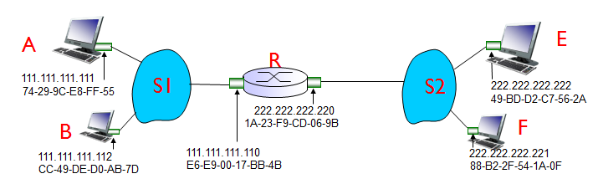

1. Consider sending an IP datagram from Host E to Host F. Will Host E ask router R to help forward the datagram? Why? In the Ethernet frame containing the IP datagram, what are the source and destination IP and MAC addresses? [2]
2. Suppose E would like to send an IP datagram to B, and assume that E’s ARP cache does not contain B’s MAC address. Will E perform an ARP query to find B’s MAC address? Why? In the Ethernet frame (containing the IP datagram destined to B) that is delivered to router R, what are the source and destination IP and MAC addresses? [3]
3. Suppose Host A would like to send an IP datagram to Host B, and neither A’s ARP cache contains B’s MAC address nor does B’s ARP cache contain A’s MAC address. Further suppose that the switch S1’s forwarding table contains entries for Host B and router R only. Thus, A will broadcast an ARP request message. What actions will switch S1 perform once it receives the ARP request message? Will router R also receive this ARP request message? If so, will R1 forward the message to Subnet 3? Once Host B receives this ARP request message, it will send back to Host A an ARP response message. But will it send an ARP query message to ask for A’s MAC address? Why? What will switch S1 do once it receives an ARP response message from Host B? [5]

**Question No.6: [10 Marks]**

Consider the network setup shown in the figure below. Suppose that the ISP instead assigns   
the router the address 24.34.112.235 and that the network address of the home   
network is 192.168.1/24.  
a. Assign addresses to all interfaces using the figure below of a home network   
b. Suppose each host has two ongoing TCP connections, all to port 80 at host   
128.119.40.186. Provide the six corresponding entries in the NAT translation   
table.

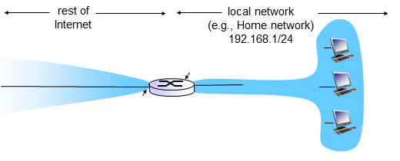

|  |  |
| --- | --- |
| **NAT Translation Table** | |
| **WAN side** | **LAN side** |
|  |  |
|  |  |
|  |  |
|  |  |
|  |  |
|  |  |

**Question 7: [10 Marks]**

1. Consider the following diagram of a LAN composed of three LAN segments connected by a Switch. Assume that the Switch table starts off empty and the given sequence of frames is sent, in the given order (frame 1, frame 2, etc.). As the Switch filters the frames it is using the standard bridge-learning algorithm to fill in its table. For each frame write down to which interfaces (if any) the Bridge forwards the frame (the answer to the first one is filled in for you) Note that it is possible that in some cases the Bridge will drop the frame and not forward it. If this happens you should say so (i.e., Drop).

🖳

🖳

🖳



A

🖳

🖳

🖳

🖳 🖳 🖳

B

C

D

E

F

I

H

G

3

1

2

|  |  |  |  |
| --- | --- | --- | --- |
| Frame | Source node | Destination node | Bridge forwards frame to interfaces |
| 1 | G | A | 1,2 |
| 2 |  |  |  |
| 3 |  |  |  |
| 4 |  |  |  |
| 5 |  |  |  |
| 6 |  |  |  |
| 7 |  |  |  |
| 8 |  |  |  |
| 9 |  |  |  |
| 10 |  |  |  |